Chapter 1
INTRODUCTION
With the increasing need for portability, sustainability, and efficiency in everyday products, multipurpose tools have gained significant importance. One such innovative product is multipurpose double-ended travel cutlery, which is specially designed to address the challenges faced by people while eating on the go. Whether traveling, camping, trekking, or working long hours outside, carrying multiple utensils can be inconvenient and unhygienic. Double-ended travel cutlery overcomes this problem by integrating two functional eating tools into a single compact unit.
This cutlery typically features different utensils on each end, such as a spoon on one side and a fork or knife on the other. The dual-function design minimizes space usage while maximizing utility, making it highly suitable for modern lifestyles. Its lightweight and ergonomic structure ensures ease of use, while the balanced design allows comfortable handling from both ends.
Another important aspect of multipurpose double-ended travel cutlery is its contribution to environmental sustainability. With growing awareness about plastic pollution, reusable travel cutlery provides an eco-friendly alternative to disposable plastic utensils commonly used during travel and takeaways. These cutlery sets are often made from durable materials such as stainless steel, bamboo, or food-grade polymers, ensuring long life, safety, and easy maintenance.
Additionally, multipurpose double-ended travel cutlery supports hygiene and personal health. Carrying personal utensils reduces dependence on shared or disposable cutlery, which may not always meet cleanliness standards. Its compact size allows it to fit easily into lunch boxes, backpacks, or travel kits, making it a practical choice for students, office workers, outdoor enthusiasts, and frequent travellers.
In conclusion, multipurpose double-ended travel cutlery is a smart, cost-effective, and sustainable solution that combines functionality, convenience, and environmental responsibility. Its innovative design aligns perfectly with the needs of today’s mobile and eco-conscious society, making it an essential accessory for modern living.
Chapter 2
Problem Statement
2.1 Description
In the present lifestyle, people frequently eat outside their homes due to travel, work schedules, academic commitments, and outdoor activities such as camping and trekking. In such situations, individuals often depend on disposable plastic cutlery or unhygienic shared utensils. Disposable cutlery contributes significantly to environmental pollution, while shared utensils may pose health and hygiene risks. Additionally, carrying separate utensils such as a spoon, fork, and knife increases luggage weight, occupies more space, and reduces convenience during travel.
Existing travel cutlery solutions are often bulky, require carrying multiple components, or lack multifunctionality. Many designs do not adequately address portability, user comfort, durability, and ease of cleaning at the same time. This creates a need for a compact, efficient, and sustainable eating solution that can be easily carried and used in various travel and outdoor scenarios.
Multipurpose double-ended travel cutlery aims to overcome these limitations by integrating multiple eating functions into a single utensil. By combining two tools into one, it reduces the number of items required, enhances portability, and supports environmentally responsible practices through reusability.

2.2 Challenge Statement
The key challenge is to design and develop a compact, lightweight, and ergonomic multipurpose double-ended travel cutlery that effectively combines multiple functions without compromising user comfort, hygiene, safety, or durability. The product must be easy to carry, safe for food consumption, simple to clean, and strong enough to withstand regular use.
Additionally, the design must ensure proper balance and usability from both ends, prevent cross-contamination between food types, and be suitable for users of different age groups. Achieving multifunctionality while maintaining affordability, sustainability, and aesthetic appeal presents a significant design and engineering challenge.

Chapter 3
3.1 Design Thinking Process
The design thinking process is a user-centered, iterative approach used to develop innovative and practical solutions. For the development of multipurpose double-ended travel cutlery, the design thinking process ensures that the final product effectively meets user needs related to convenience, hygiene, sustainability, and portability. The process consists of the following stages:
1. Empathize
In this stage, the needs, problems, and experiences of users such as travelers, students, office workers, and outdoor enthusiasts are studied. Observations and interactions reveal that users often face difficulties such as reliance on disposable plastic cutlery, lack of hygienic eating tools, and inconvenience in carrying multiple utensils. Understanding these pain points helps define the real problem from the user’s perspective.
2. Define
Based on insights gathered during the empathize stage, the problem is clearly defined. Users require a compact, reusable, and hygienic eating solution that is easy to carry and suitable for various food types. The defined problem statement focuses on designing a single tool that combines multiple eating functions while ensuring comfort, safety, and durability.
3. Ideate
In this phase, multiple creative ideas and concepts are generated to solve the defined problem. Brainstorming sessions lead to various designs combining spoon, fork, and knife functions in a double-ended format. Concepts are explored with different shapes, locking mechanisms, materials, and storage solutions. The most promising ideas are shortlisted based on usability, simplicity, and feasibility.
4. Prototype
The selected design concept is transformed into a physical or digital prototype. Initial prototypes are created using sketches, CAD models, or 3D-printed samples. These prototypes help visualize the design, test ergonomics, and evaluate the balance and functionality of the double-ended cutlery in real-life usage scenarios.
5. Test
The prototype is tested by users to assess comfort, ease of use, hygiene, durability, and cleaning convenience. Feedback is collected to identify improvements related to grip, size, weight, and safety. Based on the test results, design modifications are made, and the process is repeated until an optimized solution is achieved.

3.2 Methodology
The methodology adopted for designing and developing the multipurpose double-ended travel cutlery follows a systematic and user-centered approach. It focuses on identifying user needs, conceptualizing innovative solutions, selecting appropriate materials, and validating the design through testing and evaluation. The steps involved are as follows:
1. User Need Identification
The first step involves understanding the needs and problems faced by travellers, students, office workers, and outdoor enthusiasts while eating on the go. Common issues such as lack of hygiene, dependence on disposable plastic cutlery, inconvenience of carrying multiple utensils, and storage difficulties are identified through observation and informal surveys.
2. Market and Literature Study
Existing travel cutlery products and designs are studied to analyze their features, limitations, materials used, and cost. This helps in identifying gaps in current solutions and ensures that the proposed design offers improved functionality, portability, and sustainability.
3. Concept Development
Based on the identified requirements, multiple design concepts for double-ended cutlery are generated. Each concept integrates two eating functions (such as spoon–fork or fork–knife) into a single tool. Concepts are evaluated based on criteria such as ease of use, compactness, balance, safety, and manufacturability.
4. Material Selection
Suitable materials are selected considering food safety, durability, weight, corrosion resistance, and ease of cleaning. Commonly considered materials include stainless steel, bamboo, and food-grade polymers. The final material choice ensures long product life and user safety.
5. Design and Modelling
The selected concept is converted into detailed sketches and 2D/3D models using design software. Ergonomic factors such as grip comfort, length, and edge safety are carefully incorporated to ensure usability from both ends of the cutlery.
6. Prototype Development
A prototype of the multipurpose double-ended travel cutlery is fabricated using available manufacturing methods such as 3D printing, machining, or molding. The prototype represents the actual size, shape, and functionality of the final product.
7. Testing and Evaluation
The prototype is tested for functionality, strength, balance, ease of handling, hygiene, and cleaning efficiency. User feedback is collected to identify any design flaws or areas for improvement.
8. Design Improvement and Finalization
Based on test results and feedback, necessary modifications are made to improve performance, comfort, and durability. The final design is optimized for mass production and practical use.

3.3 Prototype Description
3.3 Prototype Description
The prototype of the Multipurpose Double-Ended Travel Cutlery was developed to provide a compact, hygienic, and reusable eating solution suitable for travel and daily use. The prototype integrates two functional eating tools into a single unit while maintaining ergonomic comfort, durability, and ease of cleaning.
3.3.1 Materials Used
1. Stainless Steel (Food-Grade – AISI 304)
Description:
Stainless steel is used for the functional ends of the cutlery (spoon, fork, or knife). It is widely used in food utensils due to its excellent strength, corrosion resistance, and food safety.
Specifications:
- Material grade: AISI 304
- Density: ~8 g/cm³
- Corrosion resistance: High
- Food safety: Approved for food contact
- Finish: Polished / brushed surface
Advantages:
- Durable and long-lasting
- Easy to clean and hygienic
- Resistant to rust and stain
2. Food-Grade Plastic (Polypropylene – PP)
Description:
Food-grade polypropylene is used for the central grip area of the cutlery. It improves handling comfort and reduces heat transfer from hot foods.
Specifications:
- Material type: Polypropylene (PP)
- Density: ~0.9 g/cm³
- Heat resistance: Up to 100°C
- Toxicity: Non-toxic, BPA-free
Advantages:
- Lightweight
- Comfortable grip
- Cost-effective
- Easy to mold into ergonomic shapes
3. Optional Alternative Material – Bamboo
Description:
Bamboo can be used as an eco-friendly alternative for the handle portion. It is biodegradable and sustainable.
Specifications:
- Material: Natural bamboo
- Weight: Lightweight
- Environmental impact: Biodegradable
Advantages:
- Eco-friendly
- Aesthetic appearance
- Sustainable material

3.3.2 System Diagram

Chapter 4
Implementation
Implementation can be optimized into three simple steps: First, finalize the design by selecting a practical double-ended combination (such as spoon–fork or spoon–knife) and deciding on compact dimensions that ensure comfort, balance, and safe edges for everyday use. Next, choose suitable food-grade materials like stainless steel or durable plastic and manufacture the cutlery using molding or cutting processes, followed by polishing and adding a non-slip grip for better handling. Finally, test the product for durability, hygiene, and ease of use, then package it with a protective cover or case so it remains clean, portable, and ready for travel, camping, or daily use.

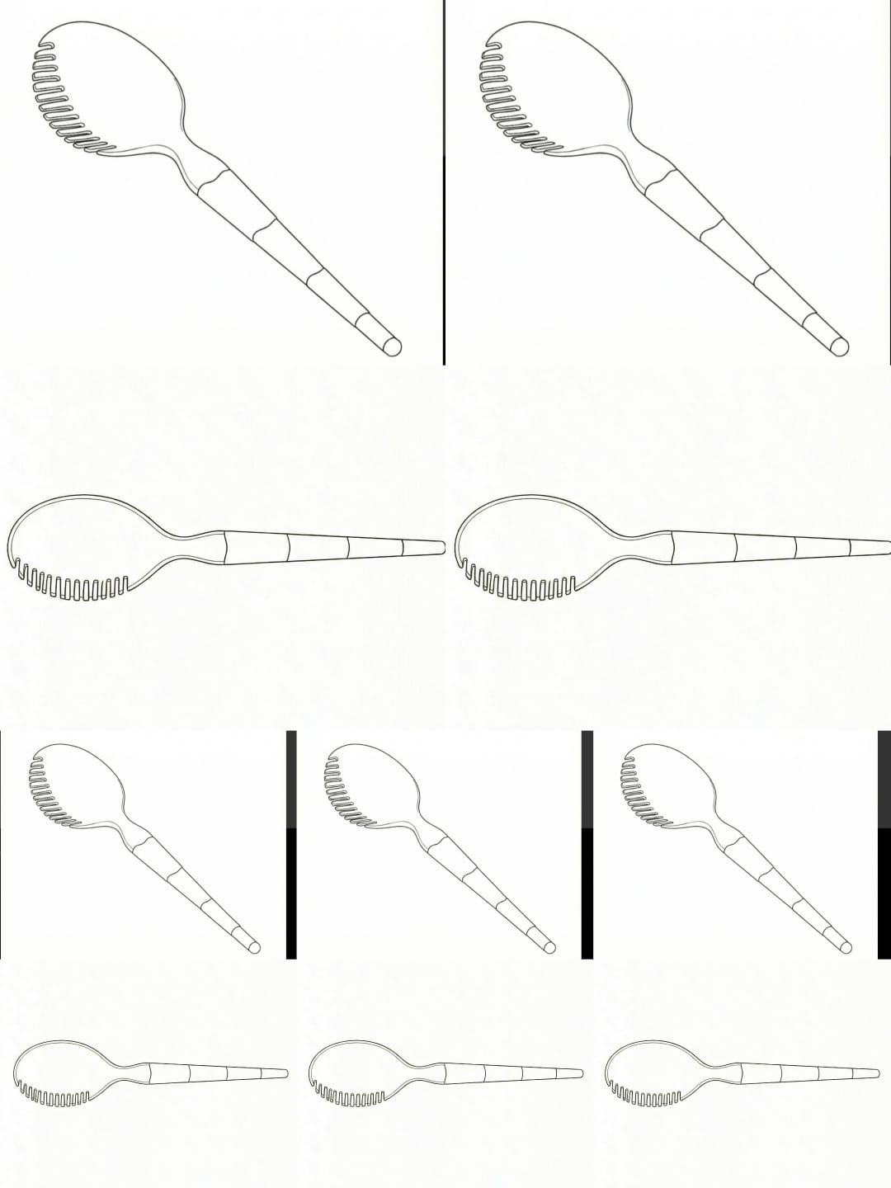

Chapter 5
Results and Analysis
User Testing & Feedback
User testing was conducted to evaluate the functionality, comfort, usability, and overall acceptance of the multipurpose double-ended travel cutlery. A prototype was tested by a diverse group of users including students, office workers, and frequent travelers. The testing process involved real-time usage during meals and simulated travel conditions.
Testing Method
- Users were asked to use the cutlery for different types of food such as rice, noodles, fruits, and snacks.
- Ease of handling, balance, grip comfort, and switching between ends were observed.
- Users provided feedback through questionnaires and informal discussions.

For Hardware Project
Photographs of the hardware setup and output are included. A short explanation is provided to describe the working and observed results of the hardware implementation.
Results
1. Functionality
Most users reported that the double-ended design effectively replaced the need for carrying separate utensils. The spoon and fork/knife ends performed their intended functions efficiently for common food types.
Observation:
✔ High functional efficiency
✔ Reduced dependency on disposable cutlery
2. Ergonomics and Comfort
Users found the grip comfortable and the length appropriate for regular use. Proper weight distribution allowed easy usage from both ends without discomfort.
Feedback:
- 85% of users found the cutlery comfortable to hold
- Minor suggestions included adding textured grips for better handling
3. Portability
The compact and lightweight nature of the cutlery was highly appreciated. Users found it easy to store in lunch boxes, backpacks, and travel pouches.
Result:
✔ Improved portability
✔ Suitable for daily and travel use
4. Hygiene and Cleaning
Users preferred using personal reusable cutlery over shared or disposable ones. The smooth surface allowed easy cleaning with water, and food residues did not stick easily.
User Response:
- 90% felt the product was hygienic
- Easy to clean and maintain
5. Durability
The cutlery showed good resistance to bending and wear during normal usage. Users felt confident that the product could withstand long-term use.
Result:
✔ Satisfactory strength
✔ Good material quality
Analysis
Based on user feedback, the multipurpose double-ended travel cutlery successfully meets its design objectives of convenience, sustainability, and user comfort. The results indicate strong user acceptance and practicality in real-world conditions. Minor design improvements such as enhanced grip texture and protective casing can further improve user experience.
Conclusion
User testing confirms that the proposed design is functional, user-friendly, and environmentally responsible. The positive feedback validates the effectiveness of the design thinking approach and supports the feasibility of the product for everyday and travel use.

Chapter 6
Conclusion & Future Work
6.1 Conclusion
The development of the multipurpose double-ended travel cutlery successfully addresses the need for a compact, hygienic, and eco-friendly eating solution for modern lifestyles. By combining two essential eating utensils into a single tool, the design reduces the inconvenience of carrying multiple items while enhancing portability and ease of use. The user-centered design approach ensured that comfort, balance, safety, and durability were given priority throughout the development process.
User testing and feedback confirmed that the product performs effectively for various food types and is well-suited for travel, office use, and outdoor activities. The reusable nature of the cutlery contributes to reducing dependency on disposable plastic utensils, thereby supporting environmental sustainability. Overall, the project demonstrates that thoughtful design and material selection can result in a practical, affordable, and user-friendly product that meets real-world needs.
6.2 Future Work
Although the current design meets its primary objectives, several enhancements can be explored in future developments:
- Material Innovation: Use of advanced eco-friendly materials such as biodegradable composites or antimicrobial coatings to improve hygiene and sustainability.
- Improved Ergonomics: Addition of textured or rubberized grips to enhance handling, especially for wet or oily hands.
- Protective Storage: Design of a compact protective case or foldable mechanism to prevent contamination during storage.
- Additional Functionality: Integration of extra features such as a bottle opener, chopstick attachment, or collapsible design for enhanced versatility.
- Mass Production Optimization: Refinement of the design for large-scale manufacturing to reduce cost and improve market availability.
- Smart Features: Exploration of smart materials or indicators to monitor cleanliness or usage for improved user experience.
Final Remark
With further improvements and technological advancements, multipurpose double-ended travel cutlery has strong potential to become a widely adopted everyday product, promoting convenience, hygiene, and sustainable living

References

      - Ulrich, K. T., & Eppinger, S. D., Product Design and Development, McGraw-Hill Education, 2016.
      - Pahl, G., Beitz, W., Feldhusen, J., & Grote, K. H., Engineering Design: A Systematic Approach, Springer, 2007.
      - Ashby, M. F., Materials Selection in Mechanical Design, Butterworth-Heinemann, 2011.
      - Norman, D. A., The Design of Everyday Things, Basic Books, 2013.
      - Gupta, R., “Ergonomic Considerations in Hand Tool Design,” International Journal of Industrial Ergonomics, Vol. 42, No. 3, pp. 235–245, 2012.
      - Singh, A., “Sustainable Design and Environmental Impact of Reusable Utensils,” Journal of Cleaner Production, Vol. 172, pp. 145–152, 2018.
      - ISO 22000:2018, Food Safety Management Systems – Requirements for Any Organization in the Food Chain.
      - ISO 9241-210:2019, Ergonomics of Human-System Interaction – Human-Centered Design for Interactive Systems.

